Curriculum Vitae
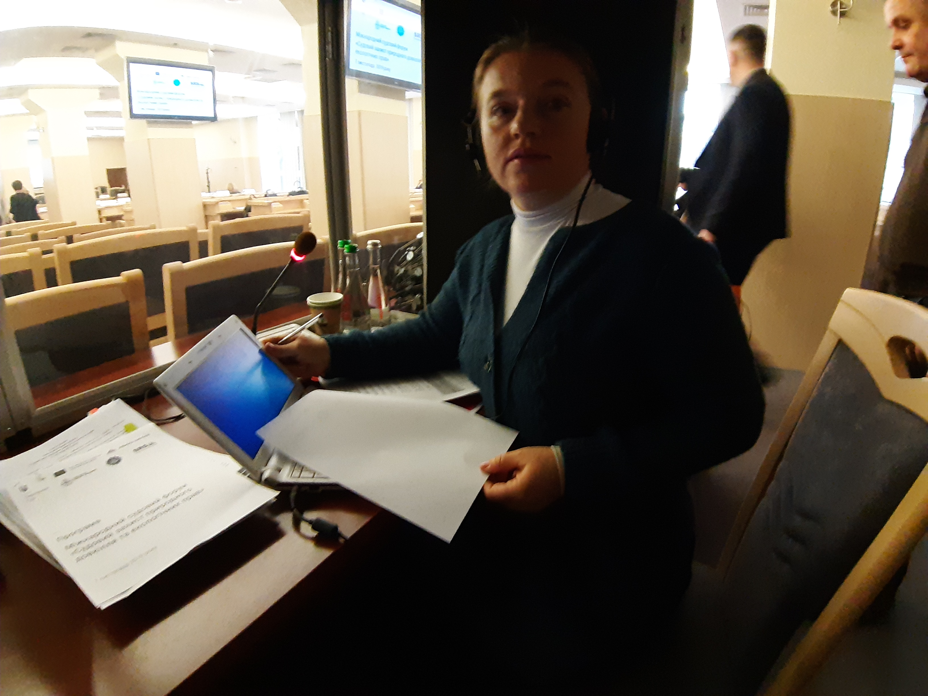

Personal:

Name: Lyashyk Valentyna
Residency Kiev, Ukraine
E-mail: lyashykvalentina@gmail.com
Web: lyashyk-translations.com.ua

Phone: 0038 067 896 80 51

Marital status: married

Languages:
Ukrainian, Russian native languages
German, English excellent

- 20 years of experience in interpretation and translation
- member of Ukrainian Translators Association (UTA) since March of 2008

Sectors:
Law, Technology, Economics, Politics, Finance, Healthcare
The main circle of my customers are as follows: courts of law, government agencies and companies.

Education:

2021 Kiev National Linguistic University
Master’s degree, diploma of interpreter/translator
(specialized in translation studies: English and German)

2001 Kiev Slavistic University
(diploma of philologist: German and Polish)

2000 Rivne State Humanitarian University
(specialized in bibliography and library science)

1996 High school
(graduated with flying colors)

Professional activity:
03.2006 – Till now: freelance interpreter and translator
My customers include:
Ministry for Transport and Communications of Ukraine,
General Prosecutor’s Office of Ukraine,
Football Federation of Ukraine,
Kyiv Administrative Court of Appeals (Ukraine),
State Traffic Inspectorate of Ukraine,
Kyiv Chamber of Trade and Commerce (Ukraine),
Vinnitsa Chamber for Trade and Commerce (Ukraine),
Gesellschaft für internationale Zusammenarbeit GmbH (GIZ) (Ukraine, Germany),
Löffler Maschinenbau GmbH (Germany),
WATTS Industries Deutschland GmbH (Germany),
Nedo GmbH Co.KG (Germany),
E.E.T. Deutschland GmbH (Germany),
Horn Glas Industries AG (Germany),
Norbert Höhne Sewing Machines (Germany),
Albrecht Meßgeräte GmbH (Germany),
Henkel Söhnlein Sektkellereien AG (Germany),
DLS Schmitt (Germany),
Haacke Haus GmbH (Germany),
Overlack AG (Germany),
Chemieanlagenbau Chemnitz GmbH (Germany),
Interkargo GmbH (Austria),
Edelstahl-Schwimmbad-und Metallbau GmbH (Germany),
Lasco Heutechnik GmbH (Austria),
Leipziger Messe International GmbH (Deutschland),
Acker Group (Deutschland),
Protock-Systems GmbH (Deutschland),
Kiev Vinery of Champagne “STOLYCHNIY” (Ukraine),
Brewery “SLAVUTICH” (Ukraine),
Gostomel-based glass factory “VETROPACK” (Ukraine),
JSC “Mironovskaya Poultry Farm” (“Nasha Ryaba” TM) (Ukraine),
“Synlab-Ukraine” Ltd (Ukraine),
JSC “VERKON” (Ukraine),
"Agro Invest Oil” Ltd (Ukraine),
JSC “Solidarnost” (Ukraine),
"Greenco Group” Ltd (Ukraine),
"Conference Hotel Service” (Ukraine) Ltd and many others.

Simultaneous and consecutive remote interpreting online via Zoom for meetings and workshops.

Translations for some German courts and translation bureaus.
Consecutive and simultaneous interpretation at the following exhibitions:

«Aqua-Therm», «Inter-Agro», «Techno+Stone», «Agri-Hort», «Restaurant Business»,«Construction and Architecture», «BauTech Ukraine», «International Realty», «Plastex», «Greenexpo», «Oil and Gas», «WineTech Ukraine», «Autodor Expo».

11.2002 – 03.2006 WATTS Industries Germany Ltd (German representative office in Kiev,
Ukraine). Consecutive interpretation and translation.
07.2002 – 10.2002 Export Import Betrieb, Kiev
Consecutive interpretation and translation.

09.2001 – 06.2002 Chamber of Trade and Commerce in Vinnitsa (Ukraine)
Translation, consecutive and simultaneous interpretation for conferences.
01.2001 – 08.2001 PODILLYA-OBST GmbH (Austrian representative office in Vinnitsa, Ukraine). Consecutive interpretation and translation.

Hobbies:
chess, alpine ski

