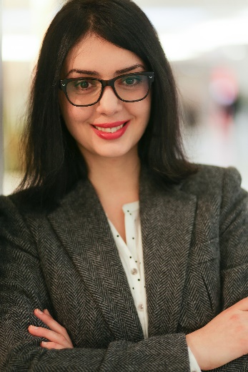

sdfsdfsdföl

**International Cultural and Business Studies B. A.**

**Translator and Interpreter**

Drießendorfer Str. 45 | 47798 Krefeld

[ch.soph@outlook.de](mailto:ch.soph@outlook.de) | +49 (0) 176 31618833

SOPHIE CHEKURISHVILI

**PERSONAL DATA**

Date of birth 26.01.1978 in Poti (Georgia)

Citizenship German

Marital status married

**SCHOOL EDUCATION AND VOCATIONAL TRAINING**

07/14 University of Nuertingen-Geislingen

**Legal German** – legal terminology for translators and interpreters

07/05 - 07/08 University of Duisburg-Essen  
**International Cultural and Business Studies**  
Majors: linguistics, literature and cultural studies (Spain, Great Britain)

Basic modules:

* New media (computer-based applications)
* Intercultural communication
* Economy

Bachelor's degree

07/00 - 07/05 University of Duisburg-Essen  
**English Studies, Romance Studies**

Majors: culture, linguistics and literature of Great Britain and Spain  
Intermediate exam

09/95 - 02/99 University of Foreign Languages and Culture in Tiflis  
**English Language and Literature**

03/99 Moving to Germany

09/84 - 05/95 Secondary school Telawi  
School leaving qualification: higher education entrance qualification

**Occupation**

06/24 **Interpreter** for the Georgian and English languages at the 2024 European Football Championship on behalf of UEFA

Since 06/16 **SAVD Videodolmetschen GmbH** – Video interpreting for municipal, health and other sectors

Georgian – German

English - German

09/16 – 12/16 **Federal Language Office**

**Language mediation**

Translation and interpretation for the Georgian armed forces during the pre-deployment training in Germany (Bundeswehr)

* Translation of training contents
* Interpretation during practical training

Since 02/15 **Self-employment**

**Authorized translator and sworn interpreter** for Georgian, German and English languages

* Liaison interpreting
* Consecutive interpreting
* Translation for public authorities (indictments, penalty orders, court decisions etc.)
* Translation of certificates, contracts etc.

11/14 – 02/15 HEUSER Recht und Steuern (organization of international employee assignments)

**Personal assistant**

* Coordination of business and personal appointments
* Travel planning, booking and preparation of appropriate travel documents
* Preparation and follow-up of meetings
* Organizational tasks

05/11 – 02/15 **Judicial authorities and law enforcement agencies**

**Part-time freelance interpreter** for German, English and Georgian

* Police and court interpreting
* Legal translation
* Conference Interpreting

11/08 – 10/14 KKG GmbH – Krefeld, (Sports betting company)

**Administrative****Assistant**

* General administrative tasks
* Support of the management in administrative and organizational issues

**Internship**

12/06 - 03/07 BUSINESS OBJECTS (Software manufacturer for business Intelligence)

**Intern**

* Maintenance of customer pools in module CRM of the system Peoplesoft
* Assistance in restructuring of database
* Revision and updating of data through internet research, in information services und through customer calls

**Continuing education**

03/10-11/12 AKAD-Privathochschulen GmbH (distance learning)

preparatory study for the state translators' examination (German - English)

**Language skills**

Languages

**Spanish** – intermediate (speaking, reading, writing)

**Russian** –intermediate (speaking, reading) basic (writing)

**Turkish** – basic

**Georgian** – native language

**German** – advanced (speaking, reading, writing)

**English** – advanced (speaking, reading, writing)

**Computer skills**

Microsoft office – advanced

Adobe InDesign CS5 – intermediate

**HOBBies**

Travelling * classic literature * behavioral psychology * football * fitness