Traduction Aperto Libro SPRL



Martine ETIENNE

Rue du 11 Novembre 57

4460 Grâce-Hollogne

BELGIUM

Mobile : 0494 27 44 16

VAT : BE 0821-730-748

Lostintranslation1961@gmail.com

Platinium member of Proz

------------------------------------------------------------------------------------------------

Court-certified translator (Belgium - Tribunal de 1ère Instance de Liège)

Born on 26 Augustus 1961.

Married, two children

Associate Degree in Translation - ISTI - Institut Supérieur de Traducteurs et Interprètes - Brussel - Belgium

French native - French mother tongue.

More than 20 years experience as translator

Since september 2011 :

* Maître-assistant at the University of Liège :
* 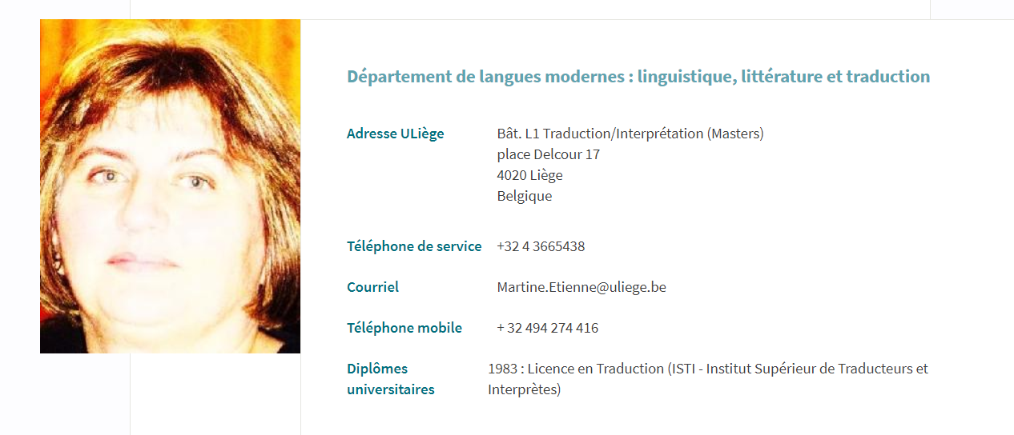
* 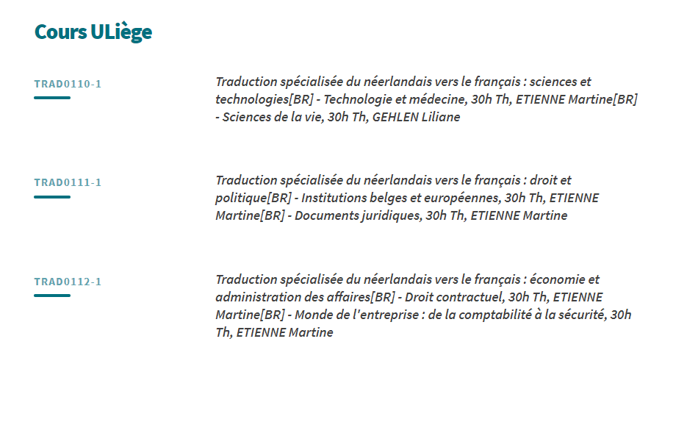

Fields of interests and expertise

* Technical specifications.
* Software manuals and help sites.
* Public relations - press releases
* Business correspondance and tenders
* Clinical trial, medical reports, drug reports.
* Environmental matters
* Annual reports
* Riding and horses

Last translations :

DU/FR : Technical tender for the TGV (100.000 words - not yet finished)

DU/FR : Grondwerken en bijzondere funderingen - Gevelsluitingen

DU/FR : Jewelry (30.000 words)

DU/FR : european environment documents ( 100.000 words)

DU/FR : SAP training manuals (more than 200.000 words) - Word and powerpoint files DU/FR : legal documents (Akten en uittreksels bekend te maken in de bijlagen tot het Belgische Staatsblad).

DU/FR : for a belgian power producer : safety courses, safey matters (dagelijkse planning, werkvoorbereiding, subnet workplanning)

DU/FR : Kwaliteitshandboek – (Quality manual) – 25,000 words

EN/FR : Hydrogen : the energy carrier (10000 words) - Helio voltaic micro central

EN/FR : Adoption files for a Belgian association

EN/FR : Marketing surveys - SDLX - 6000 words

EN/FR : air conditioning units - 30.000 words

EN/FR : computer - marketing documents

EN/FR : How to use a piezometer? Technical Manual.

EN/FR : Safety powerpoint presentation US army.

EN/FR : Installation, Operating & Maintenance Manual High Shear in Line Mixer – 3,300 words.

EN/FR : Innovative filler for a natural, lasting reslt – leaflet – 1 500 words

EN/FR : Instruction manual for testing all forms of DC power including batteries, photo-voltaïc cells, turbines, generators and electronic power supply units – 7 300 words

EN/FR : Wood dust – Material safety data - shipper cargo information sheet

EN/FR : Operators instruction for Jumbo-Weighers 4 357 words

EN/FR : last will and first grant probate – 1 200 words

EN/FR : remote control EOD vehicle cyclops – electrical drawbridge – technical manual – 7 300 words

Medical : EN/FR

* Post shave treatment for women
* Chemical and pharmaceutical glossary (2500 words)
* Diabetes : powerpoint presentation of the different diabetes
* Glaucoma and its treatment
* Medical reports
* A phase II, double-blind, placebo controlled study about moderate and severe Crohn disease.
* Going home with your child's tracheostomy - booklet for parents
* Bronchoscopy
* Briefingsdocument voor Valsartan (Diovane en Codiovane)
* Mogelijke diagnose door dermatologen van de ziekte van Fabry, een dodelijke maar behandelbare ziekte.
* Reactine pseudoephédrine alias reactine plus

Some Customers <https://www.proz.com/feedback-card/6918>

PRICES (to be negociated)

Translation – technical 0.11 €/ source word

Translation – non-technical 0.09 € /source word

These prices are an idea of the rate. Generally, I quote the document depending on the subject and difficulties.

This file contains confidential information intended for the use of the individual named above. If you are not the intended recipient of this document, please contact Martine Etienne at the above-mentioned address.