Dear Sirs.,

I am interested in your offer. I personally provide English <> Polish translations. I have M.Sc. in Engineer of Mechanics and Machine Construction.

EN-PL 0.04 EUR per word. I have 40 positive entries on proz website.

I work in Trados Studio, Memsource.com, MemoQ and Déjà Vu.

Proz link: http://www.proz.com/translator/1143865

I perform specialist translations in the areas of information technology, consumer equipment as well as financial reports, marketing and training material. The average deadline for translation of 100 pages for price calculation is 8 days.

I have many years of experience in realizing specialist **translations** in the fields of **mechanical engineering,** IT, automation**,** motorization**, building engineering,** plastic, metal, and wood working and machining technology for **leading manufacturers** of machine tools, injection presses, production lines, rolling bearings, drive transmission gears, air conditioning units, controllers, software (including CAD/CAM) and accessories for light and heavy industry.

I’m offering what I do best with words, professional copywriting in technical communication. My interdisciplinary education in linguistics and psychology of advertising has allowed me to come into my own in the creative field of marketing and to delve into the arcane art of effective promotion.

specializations: mechanics, engineering, IT motorization, telecommunications, **building engineering**, automation**,** motorization, ventilation, air conditioning, heating, metrology, materials science, controller, milling machine, computer numerical control CNC, lathe machine, drill machine

Upon request, I will send a list of references of companies for whom I perform translations.

I have obtained the title of Master of Science and Engineer of Mechanics and Machine Construction.

**My education**   
- English education - -Southgate Adult & Community Education, Michigan, USA

- Linguistics and psychology of advertising - IMBA - Warsaw University of Technology

**- Master of science** in the field of production engineering - Warsaw University of Technology – Faculty Machine Design and Maintenance, specialization: Production engineering (individual course of study). **I have M.Sc. in Engineer of Mechanics Construction.**

MAJOR RECENT PROJECTS:

**Patents**

- for P&G

- for 3M

- Mondelez

- valve system for drilling systems

- absorbent cores comprising superabsorbent polymer particles

- companies that produce biomedical laboratory instruments

Below you can find a few patents that I was translating in last 3 months period.

- Fibrous structures comprising a polymer structure  
- Sugar free isomalt confectionery and methods of making same cross reference to related applications  
- Method of correction of particle interference to hemoglobin measurement  
- Modular clabe head for optical networks  
- AZOLE DERIVATIVES, METHODS FOR PRODUCING THE SAME, INTERMEDIATES THEREOF, AGRO-HORTICULTURAL AGENTS  
- CONFECTIONERY COMPOSITIONS INCLUDING AN ELASTOMERIC COMPONENT AND A SACCHARIDE COMPONENT

# IT

LG - Translation of mobile phone, manuals and interface, website

Samsung - Translation of mobile phone (GALAXY), manuals, interface and website

Lenovo – Translation of manual for notebook, website content 20,000 words

Infradata – Translation of the website and advertising materials – 15,000 words

# Science

# - DOCTOR’S THESIS - OPTIMIMIZATION ALGORITHMS IN NON-LINEAR MODEL PREDICTIVE CONTROL – 30.000 words

**Finance**

- Enel 2014 -nuclear power stadion - 2014 Annual Report – 60.000 words (Translation agency Cardig s.r.o.)

- GEA Group – Bonus regulation

- Doosan Bobcat – General supplier agreement

- Philips – report and working agreement

**Management, Marketing, website, voice-over script and training**

- HSBC –ebsite – 60,000 words

- Adidas - 600 pages - procedure for retail staff training

- Adidas – 14,000 words merchandise procedure/policy

- COCA COLA - advertisement

- Seedcare - presentation of the agricultural business – 9,000 words

- Project Manager’s Role in New Business – Marketing and Proposal Preparation 26,000 words

- Internal Control Quality Operating System (ICQOS) - presentation and training materials – 30,000 words

- Terranova Information Security “Information Security tools” – IT course 150,000 words

- IBM - subtitles for how-to video – 45,000 words

- Aderco – subtitles for advertising movies – 5 minutes

**Cinema, movie, TV, teatr**

- IBM – subtitles for movies – 45,000 words

- subtitles for movies Prymas Tysiąclecia PL_EN – 20,000 words

- Power Ranger – 20 episodes – 400 minutes

- Aderco – subtitles for advertising movies – 5 minutes

- Life in a Fishbowl - subtitles for movies – 130 minutes

**Medicine**

- Medtronic - Surgeon Directed Neurological Monitoring – 50,000 words

- HandProd – marketing material – 20,000 words

- Globus Medical - REVLOK Fenestrated Screw System, REVOLVE* Stabilization System

- Geister Medizintechnik GmbH – Surgical Instruments

**Electric power station**

- Elektrociepłownia Rzeszów - Construction of a combined-heat-and-power plant with Diesel engines fuelled with vegetable oils - 100,000 words

- ENERGA-OPERATOR S.A. - the realization of Intermediary Infrastructure using PLC technology for ENERGA-OPERATOR S.A. – 30,000 words

**Engineering**

- Fanuc – engineering manual 200,000 words - CNC wire-cut electric discharge machine

- The Chen Hsong Group – operation manual for injection moulding machine 80,000 words

- Asian plastic machinery co., ltd - heavy duty double-toggle injection molding Machine – 70,000 words

- Dynamic tire balance system Windows® operating system – 30,000 words

- Manuals for bending machines for tubes and profiles – 400,000 words

- Manuals for lathe, milling and drilling machines – 500,000 words

- Manuals for CNC controllers (machining machines, air conditions ect) 700,000 words

**Automotive**

- KIA MOTOR - presentation of maintenance services

- Bosh - code list of car controller – 50,000 words

- LuK – description of transmission gear DSG – 5,000 words

- DOOSAN - Operation and Maintenance Manuals for excavators – 150,000 words

**Oil and gas industry**

- NIKKISO oil company - LNG HP PUMPS

- PKN Orlen S.A. oil company - foundation of installatoin. 15,000 words

- NAFTA GAZ - Odourizing unit - 19,000 words

- Norgren - Solenoids valves for oil and gas industry

- Metering pump type MAH, Micro-flowmeter, Control and power p.c.b.

- Odourant concentration controller ODR 7

- Instructions of use of the hidracar charging & control gas kit for pulsation dampers and hydropneumatic accumulators

- Energa-Operator S.A. the supply and start-up of Metering Infrastructure for Energa-Operator S.A.

- PBG S.A. - construction of the Swinoujscie LNG terminal **„**Swinoujscie LNG Regasification Terminal**”**

**Business and general text**

- Michelin – General terms and conditions of purchase, Supplier quality assurance manual, Performance and responsibility, Quality standards

- Different management contracts

- Streetbees - The World's Intelligence Platform

- Terms and conditions of sale for equipment, parts, field services and repairs for various companies.

- 3 M - Evaluation report of Preparatory Actions in the field of supervisory rating

- PGE - Terms of reference for a World Bank-financed project

- Special limited partnership agreement of XXX

- Proposal to provide professional services to Hydro Vacuum JSC Representative Office in Hanoi

- Methods of artificial intelligence in the process of identifying the quality of agri-food products

- EC declaration of conformity for various machines.

Translation companies:

- MasterWord Services, Inc - [www.masterword.com](http://www.masterword.com/)

- PPI Technical Comunications Division of Advancement - [www.ppitechcom.com](http://www.ppitechcom.com)

- Valeupoint Knowledgew.com

- Zelenka

- A2Z Global LLC

- TradAction

- ProTranslating

- Hogarth Worldwide Limited

- Skrivanek

- Synergy Language Services

- TermTron Translation Serv

- ProLangua Communication

- Sano Global Technologies

**Main objects of professional practice:**

"Jazon" - Metal Machines Factory

"Samasz" - Agriculture Machines Factory

„AWIA” – Precise Machine Tools Factory, Warsaw,

"Warsaw University of Technology" – lecturer

"Sakomet" - production company

Best regards

Karol Dobryniewski

ul. 42 Pułku Piechoty 72H lok. 19

15-181 Białystok

mobile.: +(48) 604 210 336

email: [razut@razut.pl](mailto:razut@razut.pl)

www: [www.razut.pl](http://www.razut.pl)

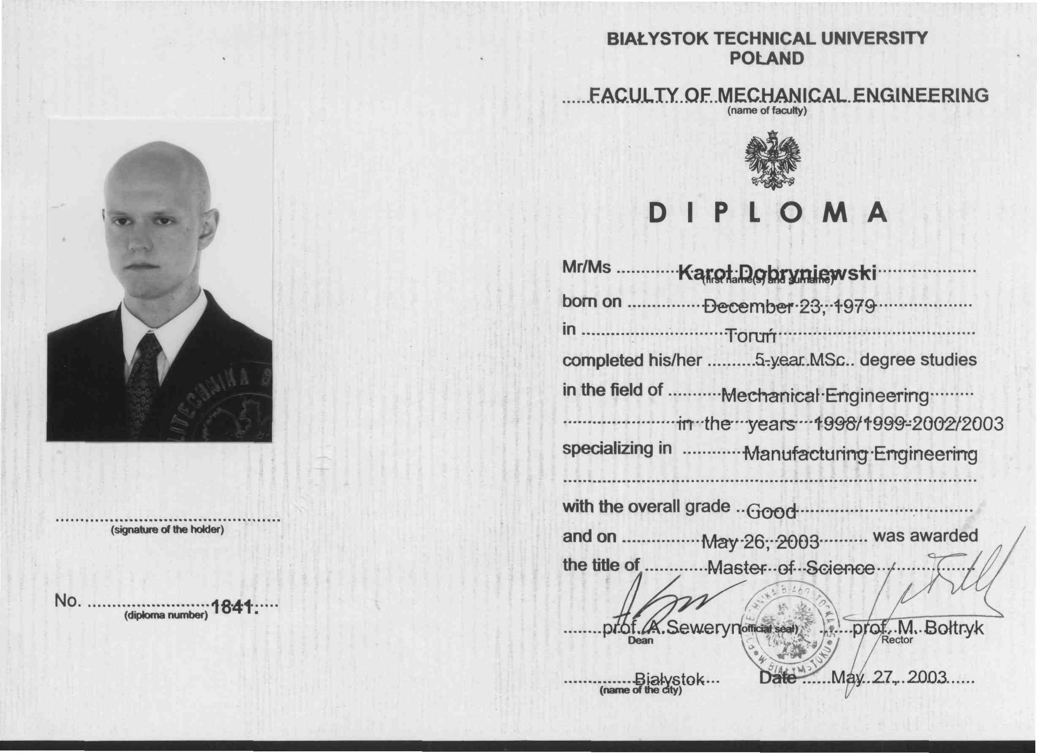

|  |  |
| --- | --- |
|  | **Karol Dobryniewski** Razut-Freelancer 42 Pułku Piechoty 72 H lok. 19,  15-181 Białystok Poland  m: [+48 604 210 336](mailto:+48%20604210336)  | e:[pulwlodarz@onet.eu](mailto:pulwlodarz@onet.eu) | w: [www.proz.com/translator/1143865](http://www.proz.com/translator/1143865) | h: Pn-Pt: 8.00 - 16.00 | |